

Preventing Burnout
Table of Contents
The program 2
What is burnout 2
Discussion question 2
Burnout defined 2
Signs and symptoms of burnout 3
Stress versus burnout 4
What causes burnout 5
Discussion question 5
Causes of burnout 6
Burnout fact or fiction 7
Fact or fiction 7
Tips to reduce burnout 9
Three R Approach 9
Turn to other people 10
Reframe the way you look at work 10
Reevaluate priorities 11
Make exercise a priority 12
Support your mood and energy with a healthy diet 13
Mindfulness 13
Emotional Wellbeing Solutions (EWS) 14
About Professional Support 15
Let’s reflect 16
References 17

The program

What is Mental Health?The Program
We will discuss these key topics about preventing burnout:


Identify what causes burnout.

Examine facts and fiction surrounding burnout.

Make a personal plan to reduce burnout.

What is burnout

What is Mental Health?
Discussion question
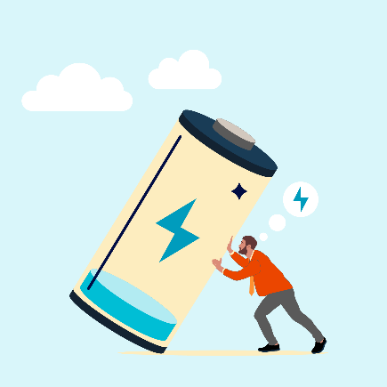
How do you define burnout?
Click here to enter your notes about how you define burnout.

Burnout Defined
The World Health Organization states “burnout is a syndrome conceptualized as resulting from chronic workplace stress that has not been successfully managed”¹. It is characterized by three dimensions:
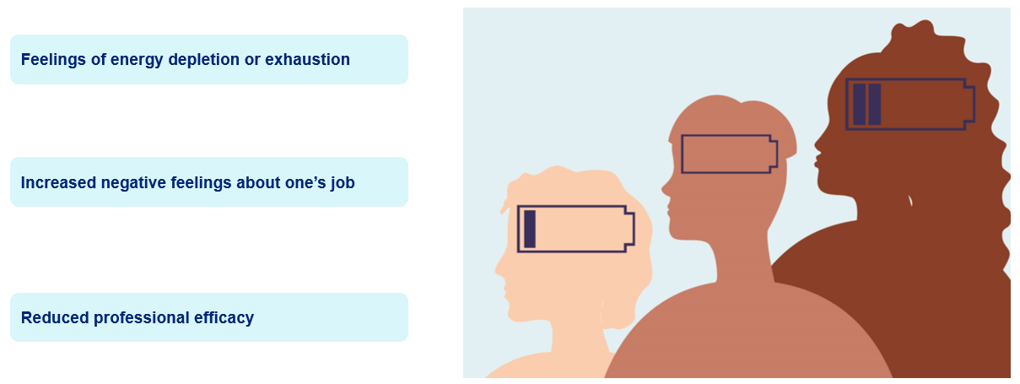
“Burnout refers specifically to phenomena in the occupational context and should not be applied to describe experiences in other areas of life.”¹

Signs and symptoms of burnout
You have days when you feel like you can’t do anything, that you are overburdened, or that no one cares about you – days when it takes every ounce of strength you have just to get out of bed. On the other hand, you might be burned out if you consistently feel this way. The process of burnout comes gradually. Although it doesn't happen right away, it can sneak up on you. Over time, the subtle initial signs and symptoms worsen. You should consider the early symptoms as warning signs that require attention.
According to the article Burnout Prevention and Treatment on HelpGuide.org, there are physical, emotional, and behavioral signs of burnout:


Physical signs²
Click here to enter your notes about the physical signs of burnout.


Emotional signs²
Click here to enter your notes about the emotional signs of burnout.


Behavioral signs²
Click here to enter your notes about the behavioral signs of burnout.

Stress versus burnout
You might be thinking burnout sounds a lot like stress. Elements of the definition of burnout could also be in the definition of stress. Certainly, some of the physical, emotional, and behavioral signs of burnout could also be signs of stress. The thing to keep in mind is that burnout and stress are not the same. To differentiate when you think of stress think “too much”² and when you think of burnout think “not enough”².
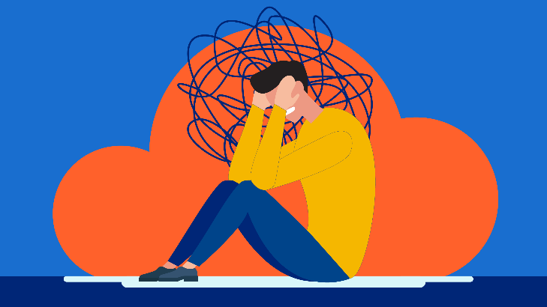
Stress = too much
An excessive number of pressures that place an excessive amount of physical and mental demands on you is what is meant by stress. Yet, when stressed you may continue to believe that you will feel better if you can just manage everything.

Burnout = not enough
Burnout is the state in which you feel empty, mentally spent, unmotivated, and beyond caring. Burnout victims frequently give up on making improvements in their circumstances.
According to the article Burnout Prevention and Treatment “If excessive stress feels like you’re drowning in responsibilities, burnout is a sense of being all dried up. And while you’re usually aware of being under a lot of stress, you don’t always notice burnout when it happens.”²

What causes burnout

StatisticsWhat can lead to Mental Illness?
Discussion question

What do you think causes burnout?
Click here to enter your notes about what you think causes burnout.

Causes of burnout
Being overworked³
When thinking of work being a cause of burnout, what comes to mind is being overworked. Being overworked is the main cause of burnout. Think about a time in your work experience where you felt overworked? Did you say anything? Or did you just find a way to do the work? Most times you don’t say no to added workload out of fear of negative repercussions immediately or in the future. What you need to get comfortable with is having conversations with your leaders about things like task priority, so you ensure you are working on the most urgent tasks first. Being comfortable with letting a leader know that your strengths don’t match what you are being asked to accomplish, and of course, letting your leader know when support is needed to complete the ask. The goal is to open a safe line of communication with your leader where you feel you can be heard and provide and receive feedback.


Recognition³
You like to be recognized for a job well done. Think about a time when you were recognized for good work. How did it make you feel? When you aren’t acknowledged for good work, you start to feel bad about yourself and question your value. Most often recognition is seen as having to come from a leader, but recognition from a coworker is just as powerful tool in helping to prevent burnout. You also need to think more broadly about recognition. Maybe a leader or coworker lent an empathetic ear at a time when you needed it. Personally, recognizing that act of kindness can help curb burnout.



Relationships³
Feeling part of the team and having social connections at work is important to our wellbeing. If you feel as if you are part of a team at work, you are more likely to flourish. Coworker interactions are beneficial to us and can help to foster a sense of support. When we don’t interact with our coworkers on a regular basis, we can end up feeling isolated⁴. This sense of isolation can contribute to burnout.


Expectations⁴
Overwhelming tasks, impractical deadlines, excessive time constraints, and poor instructions are examples of unrealistic work expectations. Burnout is more common when you are expected to complete tasks on time and consistently under pressure to meet arbitrary deadlines. In addition, there is a greater chance of burnout in work environments where tasks and instructions are unclear. When you don’t have clear instructions and expectations there is a higher probably that rework will be needed. You can become burnt out because of having to put in a lot of effort to understand what is expected of you.



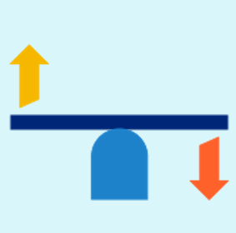
Fairness³
When you feel like you are not supported or are being treated unfairly at work, you are at an increased risk of burnout. According to the article Six causes of burnout at work, unfair treatment at work increases the risk of burnout and increased use of sick leave.


Values³
There is an increased probability that if you work for an organization where you don’t share their mission and values you will not only be miserable, ineffective, have decreased job satisfaction, but you are more likely to burnout.

As you have seen burnout is not only because you work long hours or have too many tasks to complete.⁵ The symptoms of burnout can also be brought on by a lack of control about how our work is performed, working in an environment that is conflict with your values, or when you feel you don’t have support.⁵

Burnout – fact or fiction

StatisticsWhat can lead to Mental Illness?
Fact or fiction

Burnout is associated with a lot of health risks. ☐ Fact ☐ Fiction
Click here to enter your notes about burnout and health risks.


People who feel burned out are weak and just can’t handle stress. ☐ Fact ☐ Fiction
Click here to enter your notes about burnout and being weak and unable to handle stress.


Burnout is a personal issue – not an organizational issue. ☐ Fact ☐ Fiction
Click here to enter your notes about burnout being an organizational issue.


Working less is one of the best ways to combat burnout. ☐ Fact ☐ Fiction
Click here to enter your notes about working less to combat burnout.


Making time for self-care is important. ☐ Fact ☐ Fiction
Click here to enter your notes about making time for self-care.


More sleep and time off will solve burnout. ☐ Fact ☐ Fiction
Click here to enter your notes about sleep and time off solving burnout.


A big life change isn’t necessary to get rid of burnout. ☐ Fact ☐ Fiction
Click here to enter your notes about life changes necessary to get rid of burnout.


Once you “get over it” burnout won’t come back. ☐ Fact ☐ Fiction
Click here to enter your notes about burnout not coming back.

Tips to reduce burnout

StatisticsWhat can lead to Mental Illness?
Three R Approach
Ignoring the indications of burnout or realizing you have already reached your breaking point won’t make it any easier to push through and carry on, it will only damage your physical and emotional health. It’s time to take a step back and figure out how to support yourself in overcoming burnout and experiencing good health and positivity. Burnout can be managed using the “Three R Approach” by²:

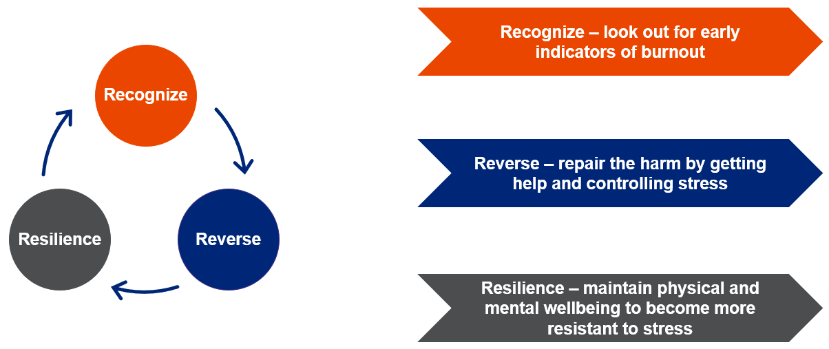


Click here to enter notes about the Three R Approach.

Turn to other people
When you're burnt out, everything seems hopeless, problems seem unsolvable, and you can barely muster the energy to care for yourself, let alone take action to improve yourself. However, you may be surprised to learn how much more power you possess. You can take constructive actions to restore balance to your life using one of the most successful tactics connecting with others.^{2 and 8}
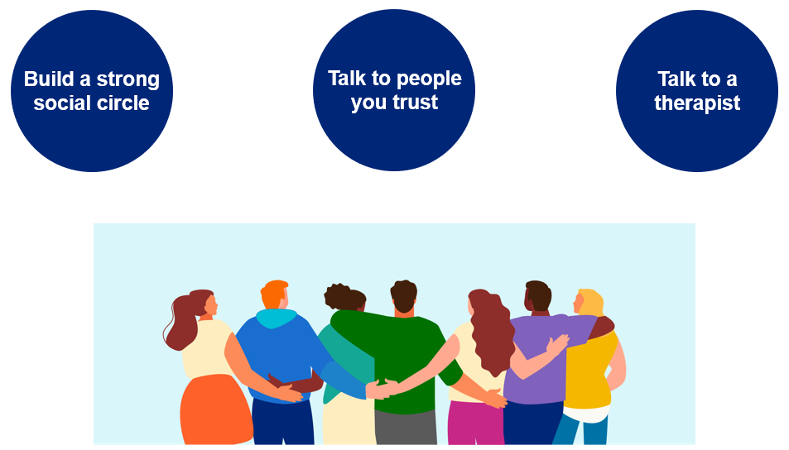

Click here to enter notes about turning to other people.

Reframe the way you look at work
You may think the best way to combat burnout at work is to quit your job and look for other employment. While that is certainly an option, it is often not a practical solution as most people do need their jobs. So, if quitting your job is not a viable option, what can you do?²

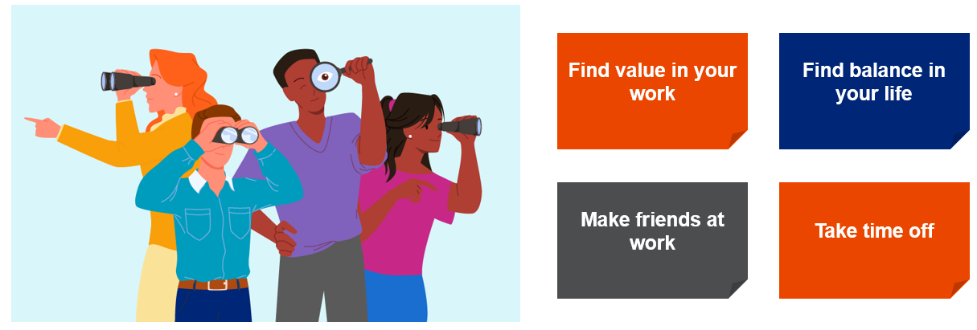
Click here to enter notes about reframing the way you look at work.

Reevaluate your priorities
An important indicator that something in your life is not going well is burnout. If you are experiencing burnout, it is time to consider reevaluating your priorities giving you the chance to find out what truly brings you joy, and take time to slow down, rest, and reflect on your life. While you are reevaluating your priorities, consider:

Set boundaries²

Fulfill his or her potential.
Enter your notes about setting boundaries.

Establish a daily routine⁹

Fulfill his or her potential.
Enter your notes about establishing a daily routine.

Nourish your creative side²

Fulfill his or her potential.
Enter your notes about nourishing your creative side.
Set aside relaxation time²

Fulfill his or her potential.
Enter your notes about setting aside relaxation time.

Take a daily break from technology²

Fulfill his or her potential.
Enter your notes about taking a break from technology.

Get plenty of sleep²

Fulfill his or her potential.
Enter your notes about getting plenty of sleep.

Make exercise a priority
Exercise is something you can do right now to improve your mood, even though it might be the last thing you feel like doing when you're burned out. It is important to callout that you must consult with your physician before beginning any exercise regimen. Exercise that involves both arm and leg movement is a very powerful tool for improving mood, boosting energy, improving focus, and promoting physical and mental relaxation. Try weightlifting, swimming, martial arts, walking, running, or even dancing. To get the most amount of stress relief, shift your attention from your thoughts to your body and how it feels as you move.²



Support your mood and energy with a healthy diet
Your mood and level of energy throughout the day can be greatly influenced by the foods you put into your body.

 | Minimize sugar and refined carbs² | Minimize sugar and refine carbs as foods containing these can cause a rapid decline in energy and mood.²
 | Minimize foods that can impact mood² | Minimize foods that can negatively impact mood “such as caffeine, unhealthy fats, and foods with chemical preservatives or hormones”.²
 | Increase omega-3 fatty acids² | Increase omega-3 fatty acids to elevate your mood by eating foods like “fatty fish, seaweed, flaxseed, and walnuts”.²
 | Avoid nicotine² | Avoid nicotine. While smoking may seem soothing during stressful times, nicotine is a strong stimulant that raises anxiety levels rather than lowers them.²
 | Consume alcohol in moderation² | Consume alcohol in moderation. Alcohol can ease worry momentarily, but when it effects wear off, too much can cause anxiety.²

Mindfulness
Taking mindfulness breaks during the day can help with burnout.


Practice self-compassion⁸
Click here to enter your notes about practicing self-compassion.


Pay attention to your needs⁸
Click here to enter your notes about paying attention to your needs.


Remember what makes you happy⁸
Click here to enter your notes about remembering what makes you happy.

Care for your mental health⁹
Click here to enter your notes about caring for your mental health.

Practice mindfulness⁹
Click here to enter your notes about practicing mindfulness.

Emotional Wellbeing Solutions (EWS)
- Short term counselling and support for all employees and immediate family members (if eligible).

- Provided at no cost to you by your employer.

- Easily accessible, voluntary, and confidential in accordance with the law – service that can provide support for personal or work-related issues.

- Staffed by experienced professionals.

“This program should not be used for emergency or urgent care, call the local emergency services phone number, or go to the nearest emergency room. This program is not a substitute for a doctor’s or professional’s care. Due to the potential for a conflict of interest, legal consultation will not be provided on issues that may involve legal action against Optum or its affiliates, or any entity through which the caller is receiving these services directly (e.g., employer). This program and its components may not be available in all locations or for all group sizes and is subject to change. Coverage exclusions and limitations may apply. The EWS information in this training is only applicable to eligible members in attendance.”

About professional support
You may consider seeking professional support if you experience any of the following:
- Sleep problems.

- Performance issues at work.

- Relationship difficulties with family or friends.

- Loss of interest in hobbies you normally enjoy.

- Lack of care about normal everyday work tasks.

- Excessive anxiety or worrying more than normal.

- Feeling overwhelmed or sad for more than two weeks.

- A noticeable change in appetite, eating too little or too much.

- Behavior and coping methods have become harmful to yourself
or others, whether that is through aggressive behavior or unhealthy habits, such as drinking too much alcohol or taking drugs.

- Thoughts of harm to self and/or others.

Keep in mind some of these conditions may warrant more urgent professional help and you should seek support if you are unsure.

Your Emotional Wellbeing Solutions (EWS) is available to all employees and their covered dependents and may include some free counseling sessions per issue, per year. Please check with your employer or your health plan for details.

Let’s reflect
Take some time to answer the questions below using the “Enter text here” boxes provided to record your answers.

- What is one thing that you have learned from this session?
Enter text here.
- What is one thing that you would like to research more?
Enter text here.

- What is one thing that you will do to help prevent burnout?
Enter text here.

References
¹World Health Organization: WHO. (28 May 2019). Burn-out an “occupational phenomenon”: International Classification of Diseases. https://www.who.int/news/item/28-05-2019-burn-out-an-occupational-phenomenon-international-classification-of-diseases. https://www.who.int/news/item/28-05-2019-burn-out-an-occupational-phenomenon-international-classification-of-diseases. Accessed 19 March 2024.
²Smith, M., MA. (5 February 2024). Burnout prevention and treatment. HelpGuide.org. https://www.helpguide.org/articles/stress/burnout-prevention-and-recovery.htm. Accessed 19 March 2024.
³Six causes of burnout at work. (n.d.). Greater Good. https://greatergood.berkeley.edu/article/item/six_causes_of_burnout_at_work. Accessed 21 March 2024.
⁴Nortje, A., PhD. (26 February 2024b). What is burnout? 16 Signs and Symptoms of Excessive stress. PositivePsychology.com. https://positivepsychology.com/burnout/. Accessed 21 March 2024.
⁵Burnout. (n.d.) Psychology Today. https://www.psychologytoday.com/us/basics/burnout?. Accessed 21 March 2024.
⁶Booth, J. (9 September 2020). 17 facts about burnout you need to know. Redbook. https://www.redbookmag.com/life/g32072571/facts-about-burnout/. Accessed 25 March 2024.
⁷Limeade. (10 June 2022). Debunking the five most common burnout myths. https://www.limeade.com/resources/resource-center/busting-burnout-myths/. Accessed 25 March 2024.
⁸Raypole, C. (9 May 2023). Burnout Recovery: 11 Strategies to Help You Reset. Healthline. https://www.healthline.com/health/mental-health/burnout-recovery. Accessed 26 March 2024.
⁹Clinic, C. (19 March 2024). What is burnout? Cleveland Clinic. https://health.clevelandclinic.org/signs-of-burnout. Accessed 28 March 2024.

